|  |  |
| --- | --- |
|  | **BIOLOGY OLYMPIAD** |
|  | **SENIOR LEVEL** |
| C:\Users\Dorcas Banda\Desktop\screen\JETS2014\zambia50.jpg | **MUCHINGA REGION JETS ASSOCIATION** |
| **2014 JETS THEME**  GOLDEN JUBILEE: ***Recognizing scientists as a driving force for national development***  **CHINSALI 2014 - 47TH PROVINCIAL FAIR**  **AT CHINSALI GIRLS SECONDARY SCHOOL**  **10TH TO 13TH JULY 2014** | |

**PROVINCIAL JETS ASSOCIATION OLYMPIADS**

**DURATION: 3 HOURS**

**INFORMATION FOR PARTICIPANTS:**

DO NOT WRITE YOUR NAME ON THE SEPARATE ANSWER SHEETS PROVIDED

WRITE ONLY YOUR IDENITICATION NUMBER ON ALL ANSWER SHEETS

ANSWER ALL QUESTIONS

DO NOT USE ANY ELECTRONIC DEVICE FOR CALCULATIONS

**QUESTION ONE**

1. The diagram below shows the metabolism of excess amino acids.

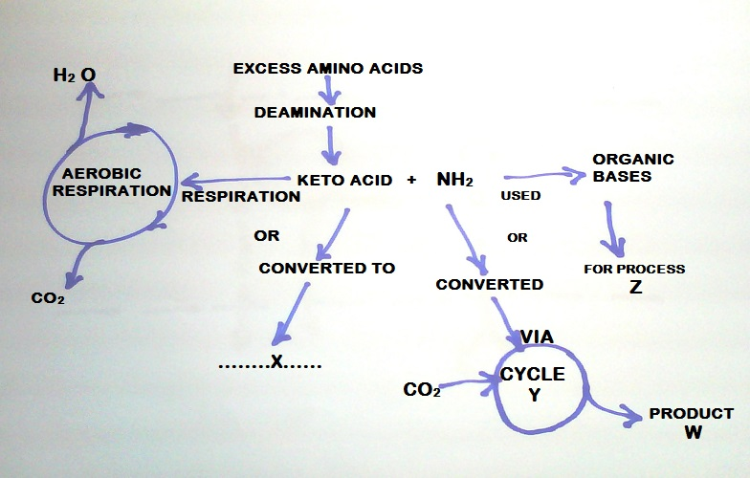

1. State products:

X. [1]

W. [1]

1. Name:

Process Z. [1]

Cycle Y. [1]

1. In which organ of the body does the above process occur? [1]
2. Outline the main functions of the skin. [3]
3. During panting in a dog, there is increased dead space ventilation as air is passed out through the mouth, over the moist tongue. Explain the role of panting to a dog. [2]

**[Total =10]**

**QUESTION TWO**

1. The diagram below shows the components of tissue respiration.

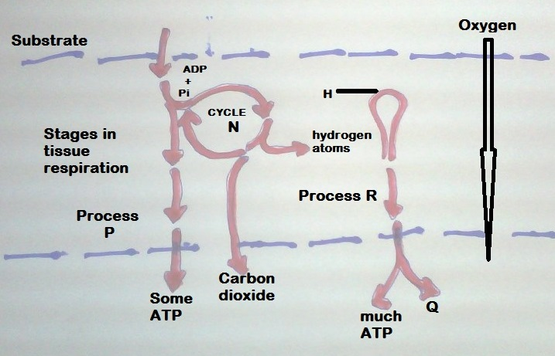

1. Name the cycle N
2. State process P
3. State product Q
4. Name process R [4]
5. Tissue respiration involves a series of reactions. What name is given to the type of reactions to which these reactions belong? [1]
6. With of the help of the diagram below,

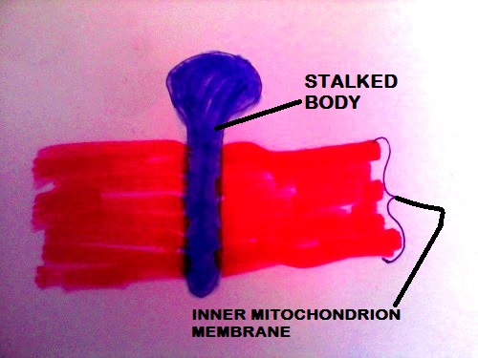

Outline the chemosprotic process that leads to ATP production in mitochondria.[5] **[Total =10]**

**QUESTION THREE**

(a)Define the following genetic terms:

(i)gene pool [1]

(ii)genetic counselling [1]

(iii)genetic drift [1]

(iv)gene splicing [1]

(b)Mr and Mrs Chanda had an hemophiliac child despite them appearing normal in the eyes of commonas.Using suitable symbols;

(i)Draw a well-labelled genetic diagram to show how this is possible. [5]

(ii)If the couple are to have 12 children,how many would be haemophiliac? [1]

**QUESTION FOUR**

Fig 1.1 shows a food web in an ecosystem.

leopard

baboon

scorpion impala

locust

grass

(a)Define the following terms:

(i) Ecosystem [1]

(ii) food web [1]

(b)(i) name the herbivore/s shown in the food web [1]

(ii) Suggest why it is difficult to state the trophic level to which the leopard belongs to in this food web. [1]

(c)In some years, there are plaques of locusts. State and explain the effect such a plaque might have on the numbers of

(i) Impala [1]

(ii) Scorpions [1]

(d)During one locust plaque, although the baboons had more food, their numbers subsequently dropped.

(i) In terms of the food web, explain how this happened. [2]

(ii)Suggest another reason, not related to the food web or hunting, for the drop in the number of baboons. [1]

**QUESTION FIVE**

(a)(i) What is the process by which sperms are made in the tests. [1]

(ii) How is the function of the urethra in males different from that of females. [1]

Fig 2.2 shows the menstrual cycle and the associated hormones.

Hormones Y and Z



HormoneX

Menstration

7 8 9 10 11 12 13 14 15 16 17 18 19 20 21 22 23 24 25 26 27 28 29 30 31 1 2 3 4 5

**Days**

(i) What is ovulation [1]

(ii) what hormones are represented by letters X,Y and Z. [3]

(iii)From fig 2.2, when is copulation likely to result into fertilization.

(iv)From the figure above, when is this woman likely to start her next periods (menstrual cycle). [1]

(c) Explain why female mammals like dogs never menstruate. [3]

**QUESTION SIX**

(a)The common broomrape, orobranhes minor, is an unusual flowering plant. It is a parasite; it has no leaves and does not contain chlorophyll.

(i) Give one feature of the common broomrape which it shares with all other plants but does not share with organisms from other kingdoms. [1]

(ii) Complete the table to show the classification of the common broom rape.

|  |  |
| --- | --- |
| **Kingdom** | **Plant** |
|  | Angiospermmaphyta |
|  | Dicotyledonae |
|  | Scrophylarales |
| Genes |  |
| Species |  |

(iii)The common poppy and the long headed-poppy are similar plants. Under natural conditions they sometimes cross to form hybrids between the two. Suggest how you could find out whether the common poppy and the long-headed poppy are different species. [2]

(b)explain how geographical isolation can lead to the formation of new species. [4]

**QUESTION SEVEN**

Study the diagrams below that show stages in cell division.

i ii



v iv iii



(a) Identify stages (i)………………………………………………………………

(ii)……………………………………………………………..

(iii)………………………………………………………………

(iv)………………………………………………………………

V………………………………………………………………..

(b)Why is the interphase referred to as a busy time? [3]

(c) What difference is between animal mitosis and plant mitosis? [1]

(d) What term describes final separation of cells in (v). [1]

**QUESTION EIGHT**

(i)Study the two organelles shown below which can be found in plant cells.

X Y

(a)identify organellel X and Y. [2]

(b)what is the relationship between between X and Y. [2]

(c) name the process that links X and Y. [1]

(d)state two differences between X and Y [2]

(ii)Water is very important to a plant .

(a)State the process by which water is uptaken from the soil and by which it is lost to the environment.

Water uptake……………………………………………………………………… [1]

Water loss…………………………………………………………………………. [1]

(b)What instrument is used to study the uptake of water by a plant? [1]

**QUESTION NINE**



The figure below shows two blood vessels in cross section.



X Y



(a)Name blood vessel X and Y. [2]

(b) State any two differences between blood vessels X and Y. [2]

(c) Name the structure that joins blood vessels X and Y.

(d)Describe the route taken by the blood as it moves from vessels Y until it joins the first vessel similar to X.

**QUESTION TEN**

The figure below shows a cell observed under a light microscope.

D A



B

Nucleus C (green)

(a)Where would this cell be found? [1]

(b)Label A,B and C. [3]

(c) What is A made up of ? [2]

(d) What pigment is found in C? [2]

(e)State the name of solution found in B. [2]